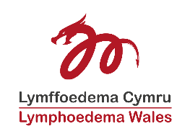
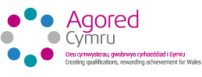
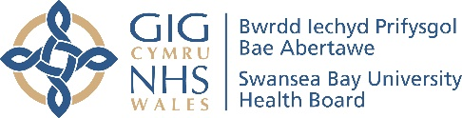
Lymphoedema Network Wales Education - Application Form 2022
To be held Virtually from, or in Class Room at Swansea University, Singleton Park, Sketty, Swansea SA2 8PP

Lymphoedema Keyworker Courses 2022 | Understanding Chronic Oedema & Lymphoedema – Virtual - Monday 14 February 2022 | £60 | ☐
 | Promoting Skin care for People with Lymphoedema to Reduce the Risk of Cellulitis – Virtual - Tuesday 15 February 2022 | £60 | ☐
 | Providing Simple Lymphatic Drainage (SLD) and other Self-managing Techniques for People with Lymphoedema – Virtual  Wednesday 16 February 2022 | £60 | ☐
 | Compression Garments – Virtual  Thursday 17 February 2022 | £60 | ☐
 | Application using Lower Limb Multi Layered Lymphoedema Bandaging Class Room Based - Tuesday 1 March 2022 | £60 | ☐
 | Application using Upper Limb Multi Layered Lymphoedema Bandaging Class Room Based - Wednesday 2 March 2022 | £60 | ☐
 | Promoting Exercise and Movement for Individuals with Lymphoedema – Class Room based - Thursday 3 March 2022 | £60 | ☐
Casley-Smith MLD Foundation  State date of Key worker course(s): ……………..……  Part 1- Online Theory  Part 2 – Lower Limb  Part 3 – Upper Limb  Part 4 – Assessment, & Mid-line Oedema | Part 1: 10 &11 May 2022  Part 2: 14 &15 June 2022  Part 3: 13 & 14 September 2022  Part 4: 18 & 19 October 2022  Part 1 is online, Part 2,3 and 4 is Class Room Based | £995 | ☐
Casley-Smith MLD Update - Advancing Clinical Practice  Date of last Casley-Smith MLD course: ………………… | 8 & 9 February 2022 – Class Room Based  7 & 8 June 2022 – Class Room Based | £295  £295 | ☐  ☐
Breast Oedema Master Class | 5 April 2022 – Class Room Based | £85 | ☐
Genital Oedema Master Class | 6 April 2022 – Class Room Based | £85 | ☐
Head & Neck Master Class | 7 April 2022 – Class Room Based | £85 | ☐

Name |  | Job Title
Address |  | Telephone Number
 |  | Mobile Number
Email
Invoice - please provide us with name & address of who Swansea Bay University Health Board will invoice

- The course fee must be paid in full prior to attending the course and this is non-refundable.
- Places will only be confirmed when we receive your payment and application form.

Please return forms to:
Lymphoedema Network Wales, Cimla Health & Social Care Centre, Neath, SA11 3SU
Tel: 01639 862767 Fax: 01639 862802 Email: Lymphoedema.Network.Wales@wales.nhs.uk

