****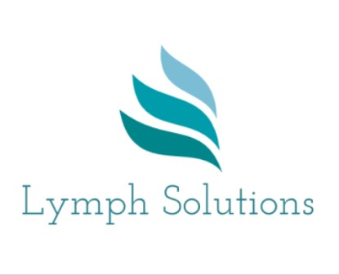

**LYMPHOEDEMA**

**CASLEY SMITH MLD UPDATE – January/February, 2024**

**Milton Keynes**

**Blended Learning**

**£290**

MLD Update - 2 half-day Zoom sessions and 1 full day face-to-face clinical session.

*Dates for Zoom sessions:*

Tues 30 Jan, 1.30 – 4.30 – focus on Head & Neck oedema,

Tues 13 Feb, 1.30 – 4.30 – case studies – discussion.

*Venue & date for the face-to-face session, “Updating Clinical Skills”:*

Monday, 5 February, 09.00 – 4.30.

Address:

The Hub. The Well, Newport Road, Willen Village, Milton Keynes, MK15 9AA.

*If you would like further information and to book a place, please contact:*

Jeanne Everett on 07983 385283 or email: [Jeanne.everett@btopenworld.com](mailto:Jeanne.everett@btopenworld.com)

*MLD Teacher (Casley Smith). CASLE (Casley Smith Lymphoedema Education UK)*

*Lymphoedema Specialist Nurse, Lymph Solutions Ltd. www.lymphsolutions.co.uk*