**** 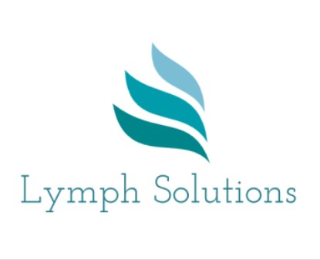

LYMPHOEDEMA: SPECIALIST SKILLS 2024

10 DAY (CASLEY SMITH) MLD COURSE

Venue: The Hummingbird Centre. Bicester

Cost £800

*Two half day Zoom sessions: 12.00 - 3pm (theory): Friday 12 Jan & Friday 9 Feb,*

*The following face to face clinical days will be from 09.00 – 16.30 :*

*Block 1: Fri 19, Sat 20 & Sun 21 Jan; MLD for upper limb lymphoedema*

*Block 2: Fri 2, Sat 3, Sun 4 Feb; MLD for lower limb lymphoedema*

*Block 3: Fri 8, Sat 9 & Sun 10 March: management of mid-line lymphoedema.*

This 10 day course will provide students with the opportunity to learn the theory and practice of advanced skills in the management of lymphoedema, including the Casley-Smith technique of Manual Lymphatic Drainage (MLD) and multi-layered lymphoedema bandaging (MLLB).

Assessments:

Formative – reviewing of MLD skills, case studies & multi choice questionnaires. Summative – MLD & bandaging skills will be assessed in block 3.

Certificate on successful completion of the course, plus admission onto the Casley-Smith database of MLD therapists (UK)

For further information, please contact:

Jeanne Everett

Lymphoedema Specialist

Email: [Jeanne.everett@btopenworld.com](mailto:Jeanne.everett@btopenworld.com)

07983 385283