**** 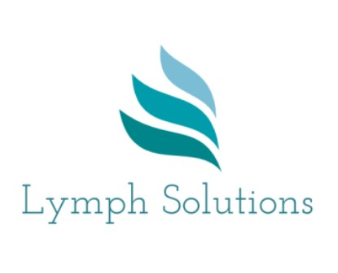

LYMPHOEDEMA: SPECIALIST SKILLS 2024

10 DAY (CASLEY SMITH) MLD COURSE

*Two half day Zoom sessions: Wednesdays 13 March & 22 May, 1.30-4.30 (theory)*

*The following face to face clinical days will be from 09.30 – 16.30 at:*

The Wolfson Suite. St Teresa’s Hospice. The Woodlands, 91 Woodland Rd,

Darlington. DL3 7UA

*Block 1: Wed 20, Thurs 21 & Fri 22 March, ,*

*Block 2: Wed 17, Thurs 18 & Fri 19 April,*

*Block 3: Wed 15, Thurs 16 & Fri 17 May*

COST: *£800*

This 10 day course will provide students with the opportunity to learn the theory and practice of advanced skills in the management of lymphoedema, including the Casley-Smith technique of Manual Lymphatic Drainage (MLD) and current available options for lymphoedema bandaging.

Assessments:

Formative – reviewing of MLD skills, case studies & multi choice questionnaires. Summative – MLD & bandaging skills assessments & case studies.

Certificate on successful completion of the course, plus admission onto the Casley Smith database of MLD therapists (UK)

For further information or to book a place, please contact:

Jeanne Everett

Lymphoedema MLD Therapist/MLD teacher (Casley-Smith)

Email: [Jeanne.everett@btopenworld.com](mailto:Jeanne.everett@btopenworld.com)

07983 385283